**PROJECT PART 4**

**Updated Assumptions:**

1. Animals can be transferred from one branch to another
2. Each shelter branch will have multiple employees
3. Each shelter branch will have a branch manager
4. Employees work only in one shelter branch only (no transfer of employees)
5. An animal can be adopted/surrendered to the shelter for various reasons multiple times
6. A vaccination is given each time an animal is detected with any disease
7. Sponsors can support multiple shelter branches
8. Full payment must be done in a single payment for adoption of an animal
9. Each medical condition of an animal is treated by only one veterinarian
10. Veterinarians can treat multiple conditions of multiple animals
11. Each transfer of an animal involves transfer from one branch to another
12. Each veterinary doctor can have multiple specializations
13. All contacts should not contain spaces
14. Employees work on hourly basis and hourly pay varies from employee to employee
15. Any animal is considered as ready for adoption if its vaccination status is up to date

**Given Queries:**

1. List the total number of dogs ready for adoption by location.

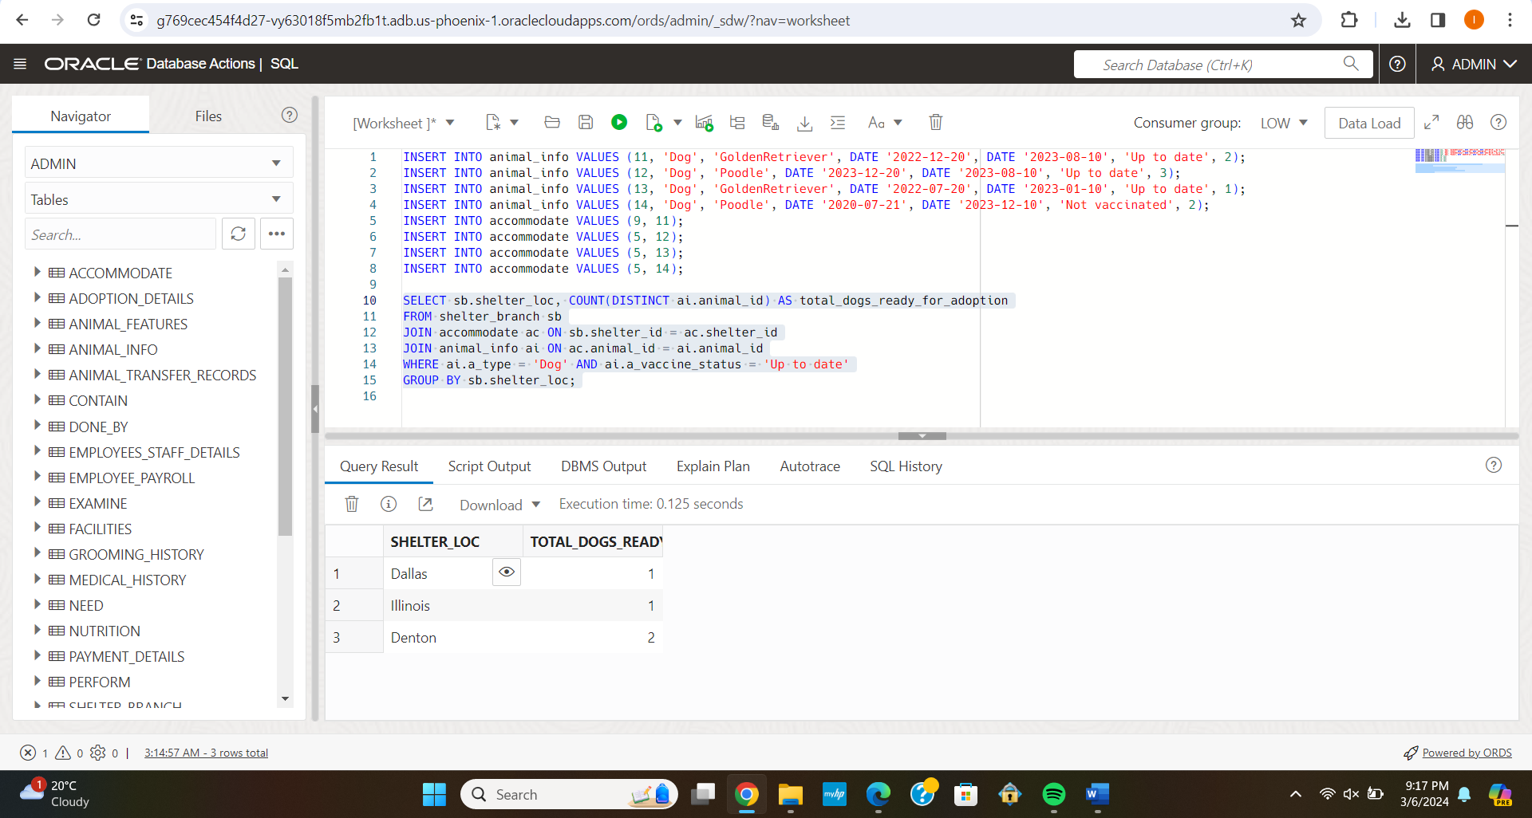

1. Find animal shelter locations without cats available for adoption:

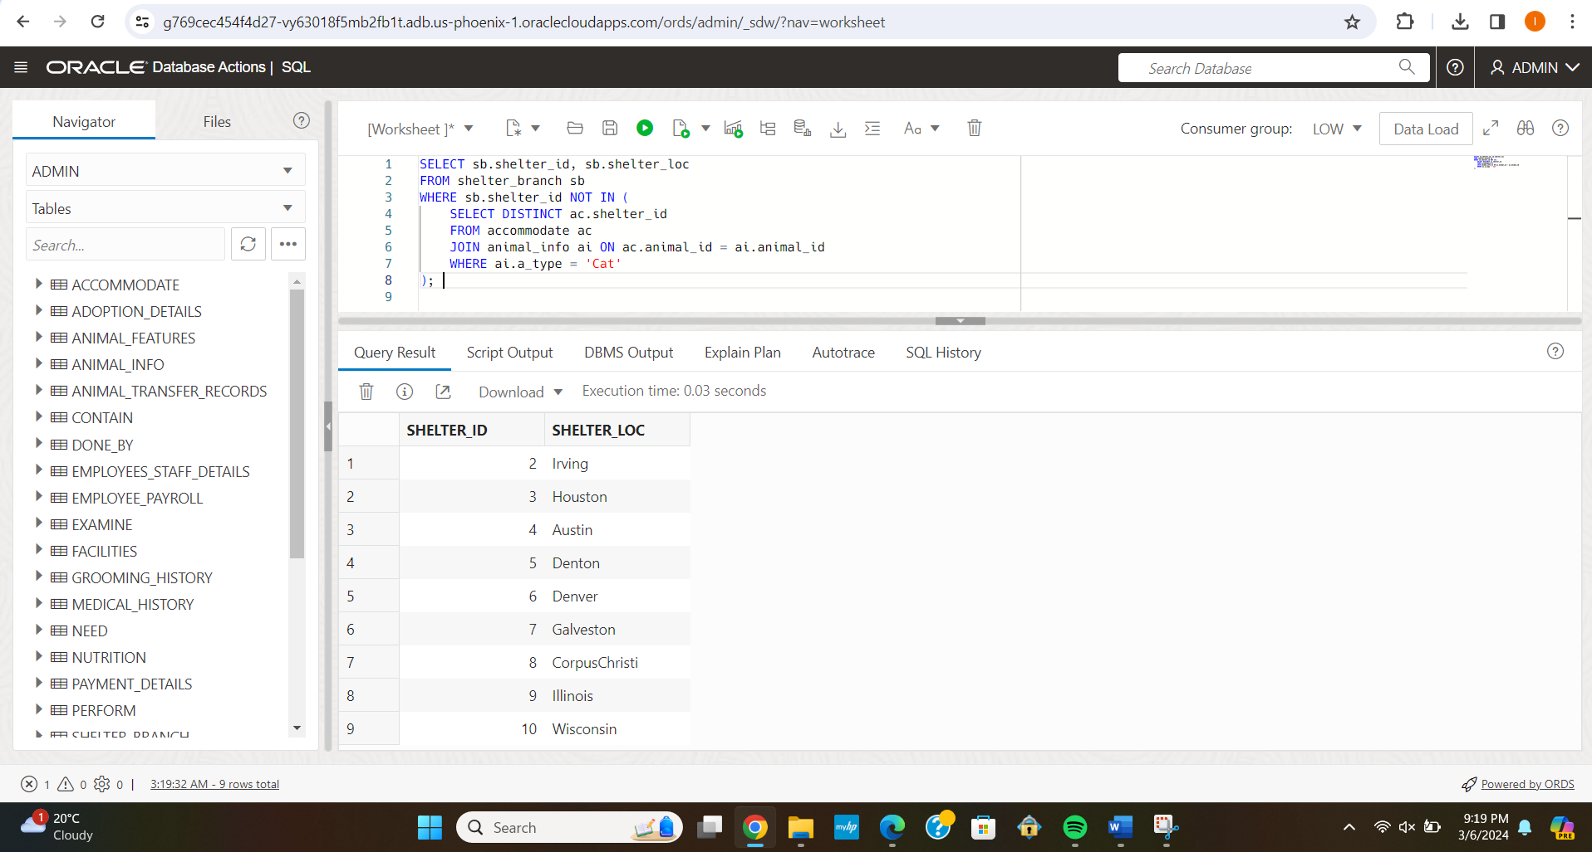

1. Find the name of the employee(s) that had worked the most hours on September3, 2023 in a shelter located in Wisconsin:

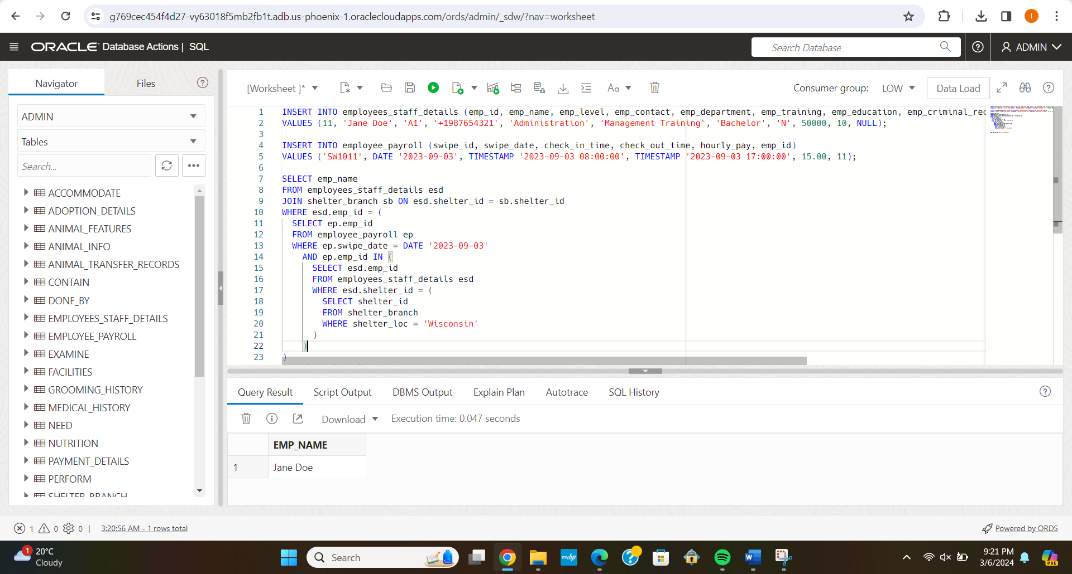

1. List the shelters that have more employees than animals hosted in their locations:

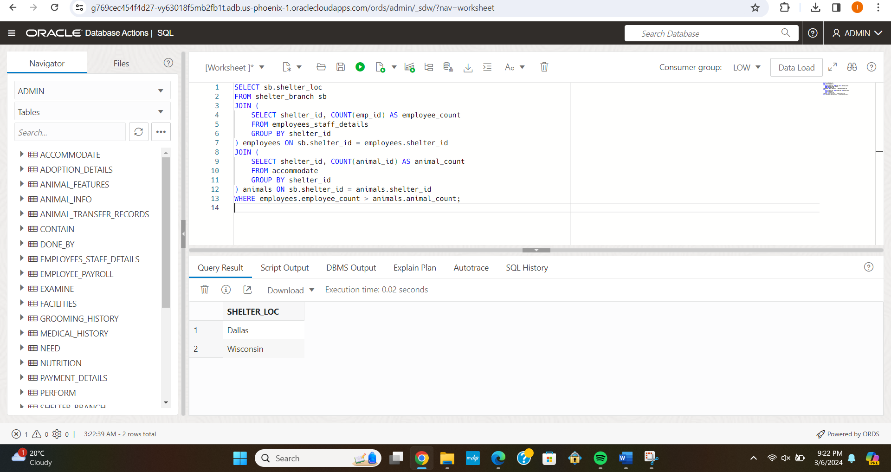

1. Print the payroll from March 4, 2022 to March 10, 2022 displaying employee name, hours worked and total salary for all employees

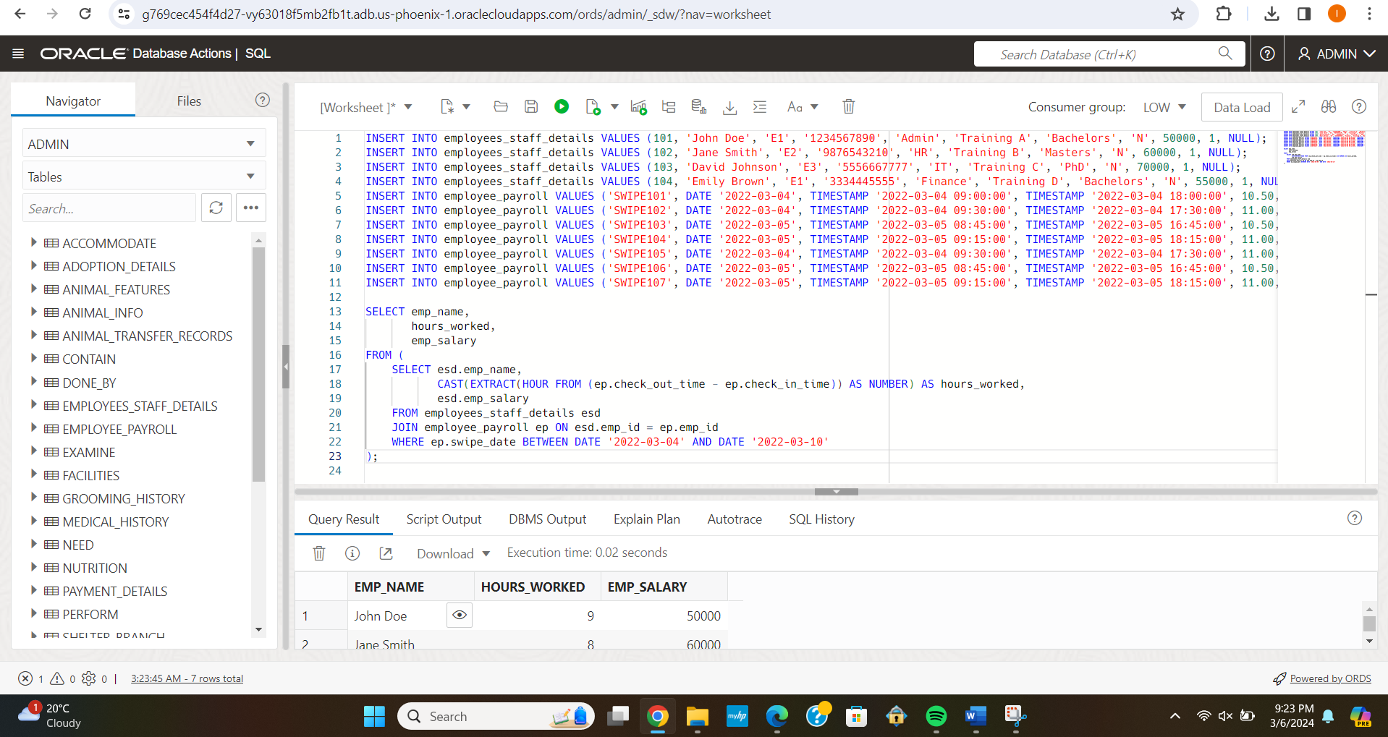

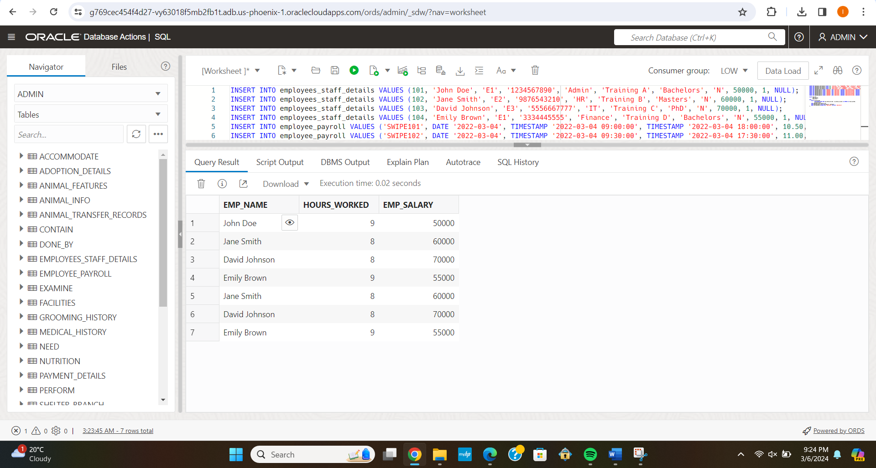

1. Design a delete statement to delete employees with criminal records working in Illinois locations:

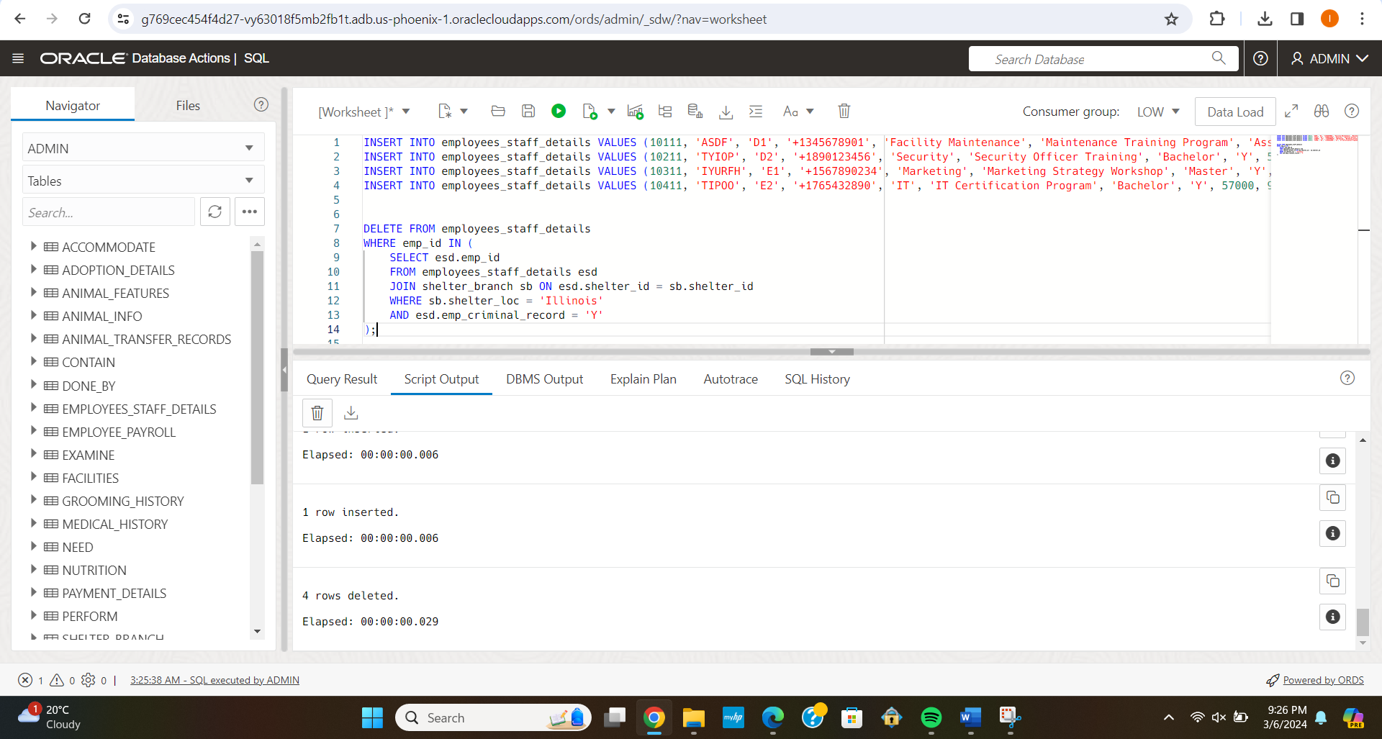

1. Design an update statement to give a 23% salary raise to employees working more than 5 hours from March 4, 2023 to March 10, 2023:

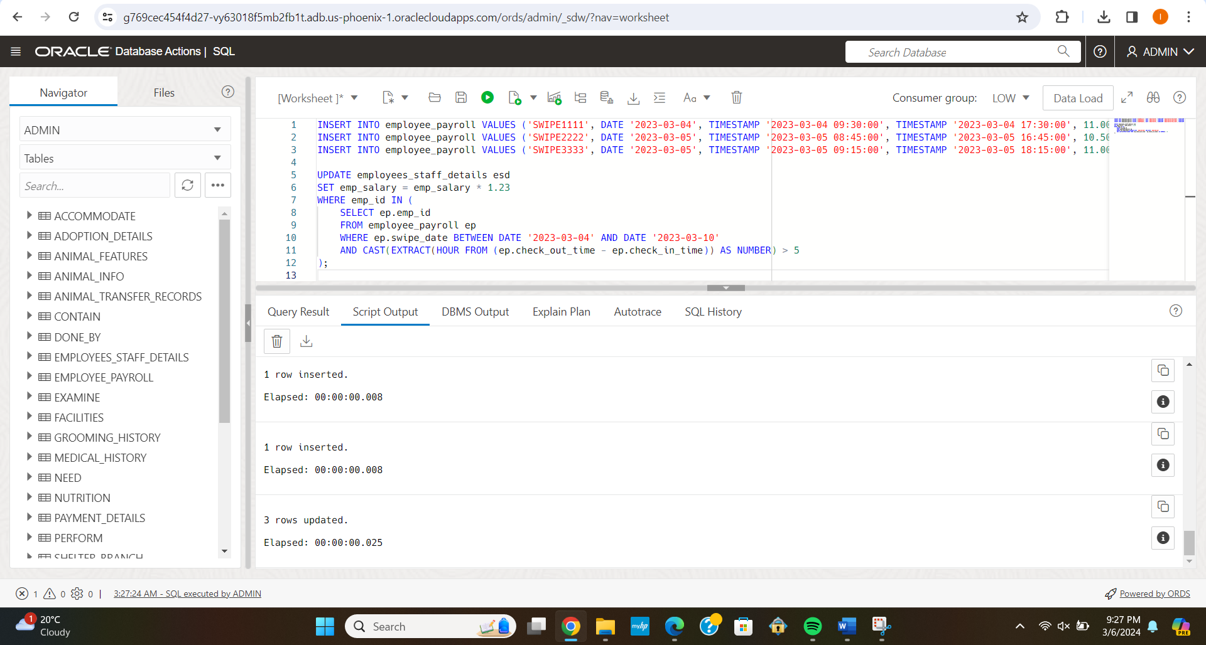

**Additional Queries:**

1. Find Avg. Weight of animals per type?

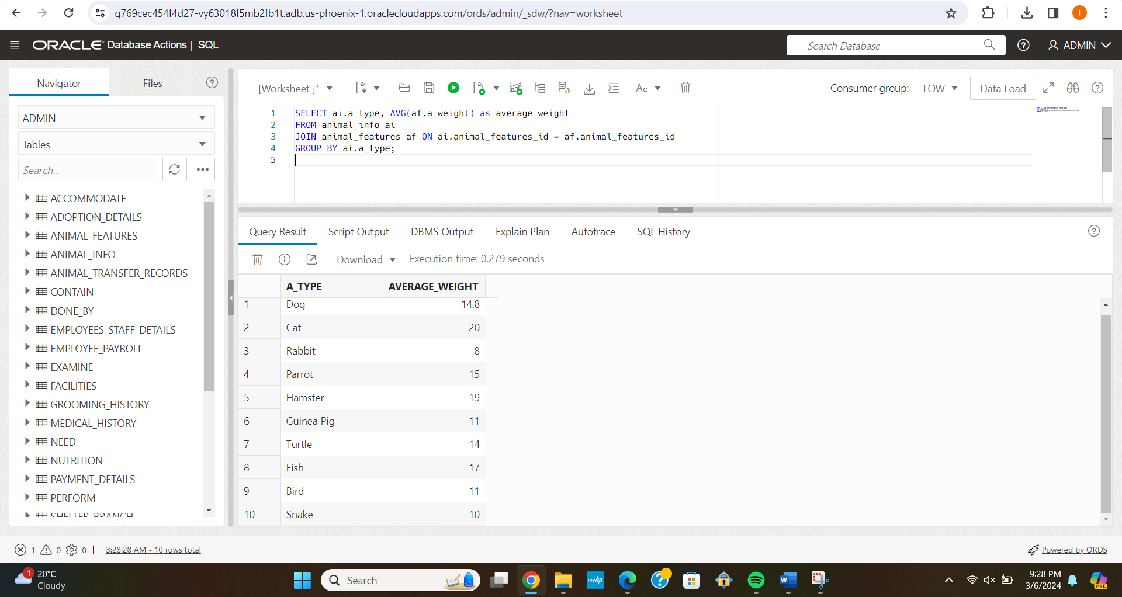

1. List the sponsors along with the total amount they have paid:

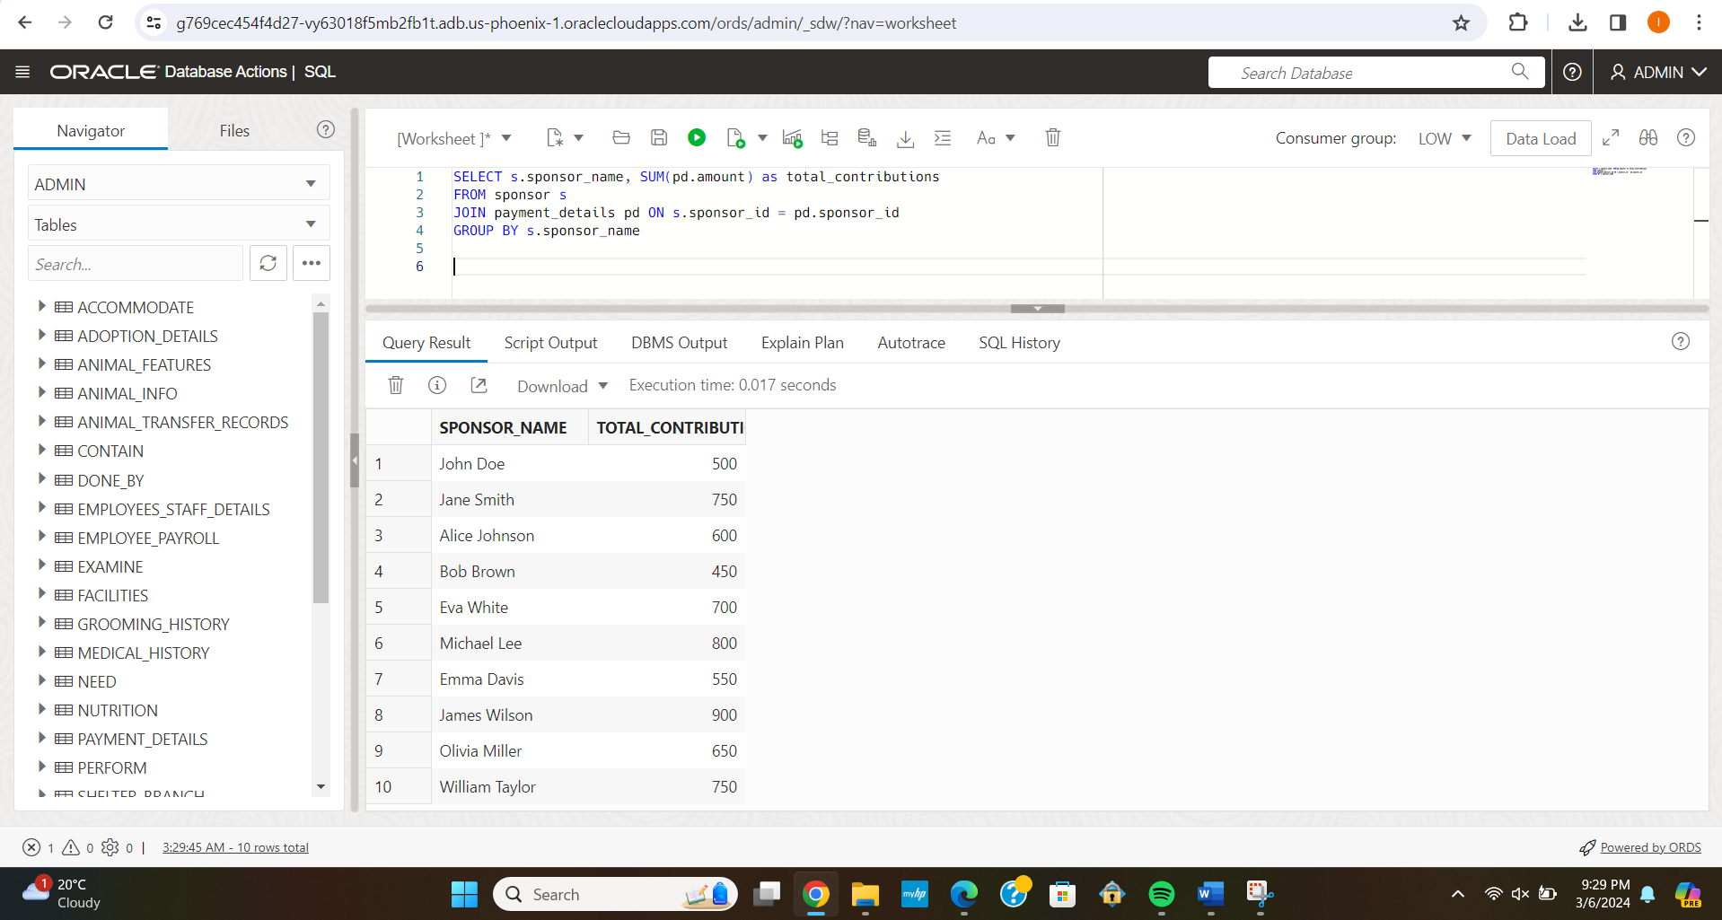

1. List the shelter locations with the highest number of dogs available for adoption:

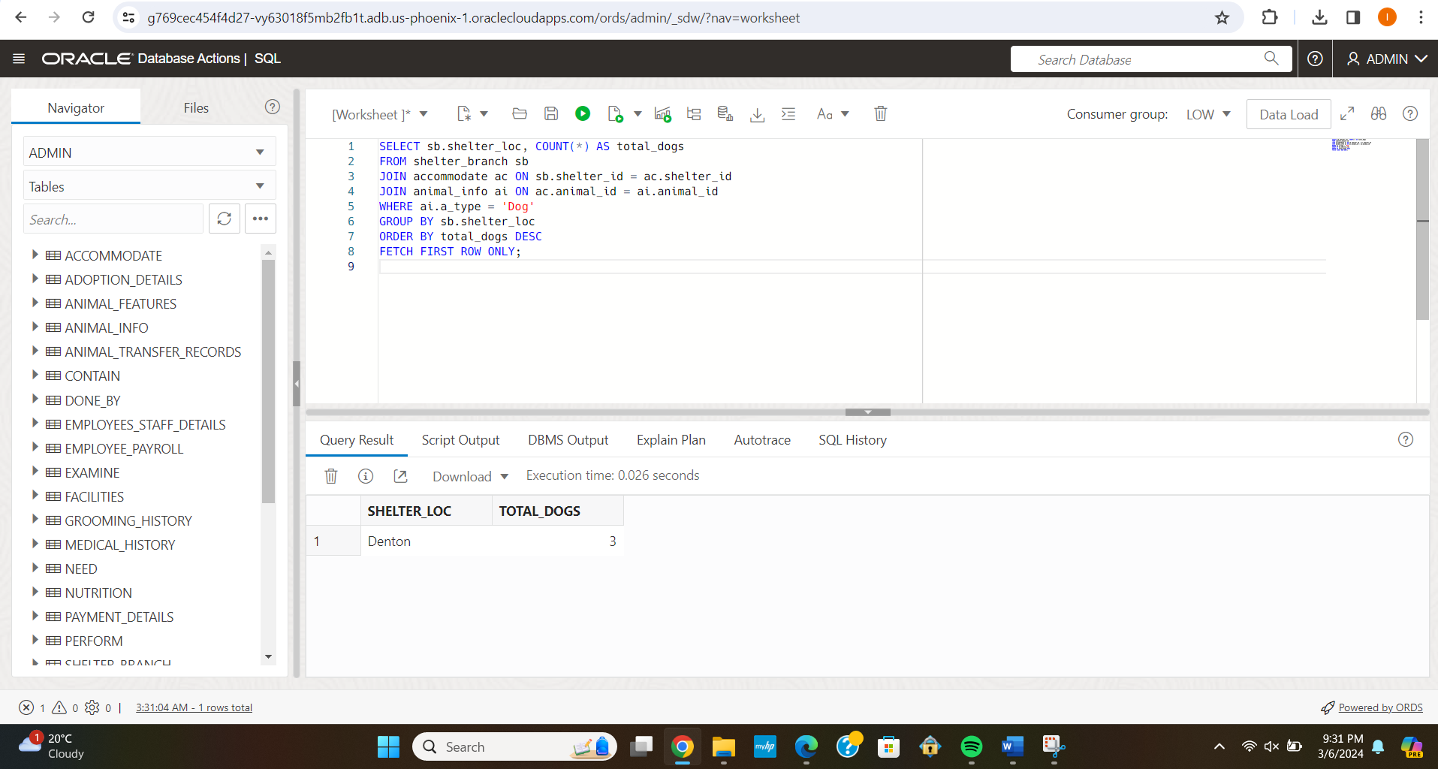

1. Find the total number of employees and animals hosted in each shelter location:

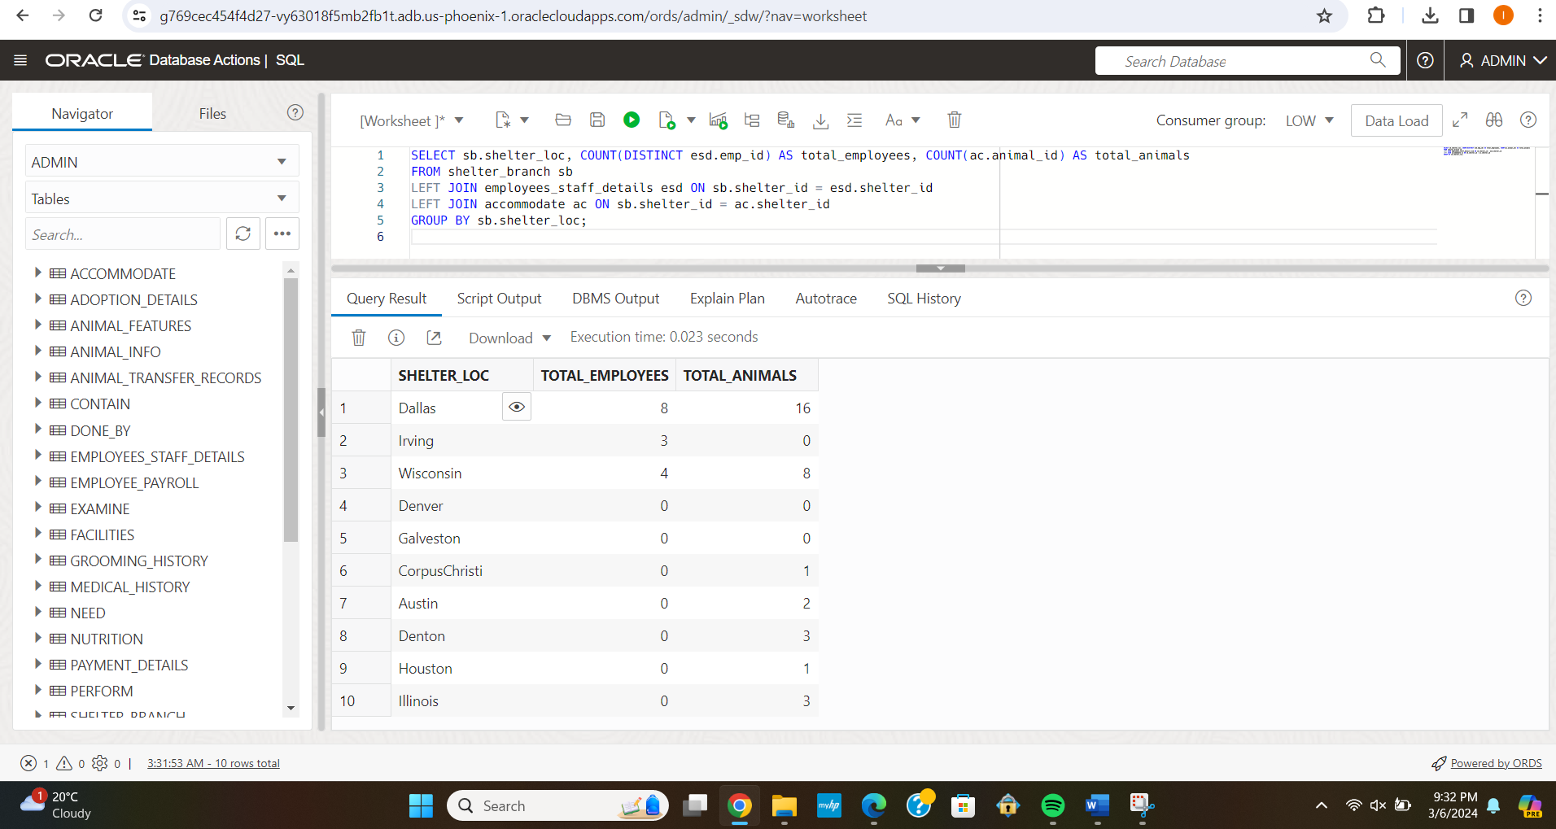

1. Calculate the total hours worked and total pay for each employee:

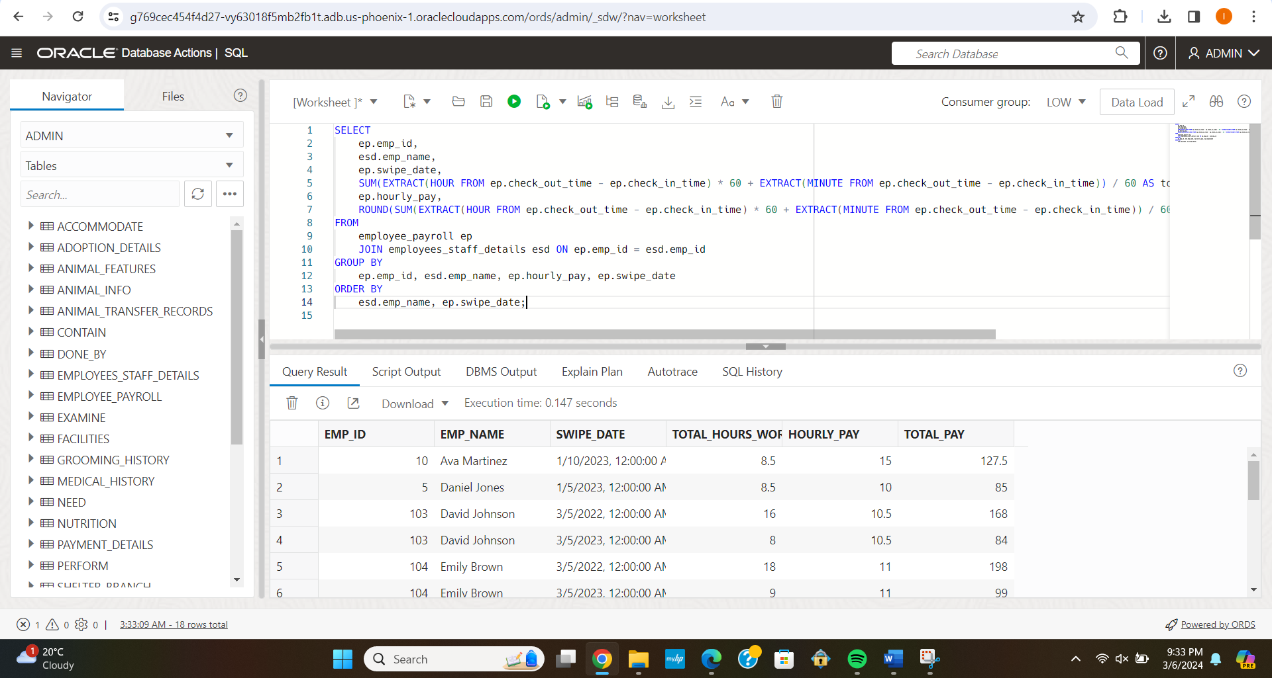

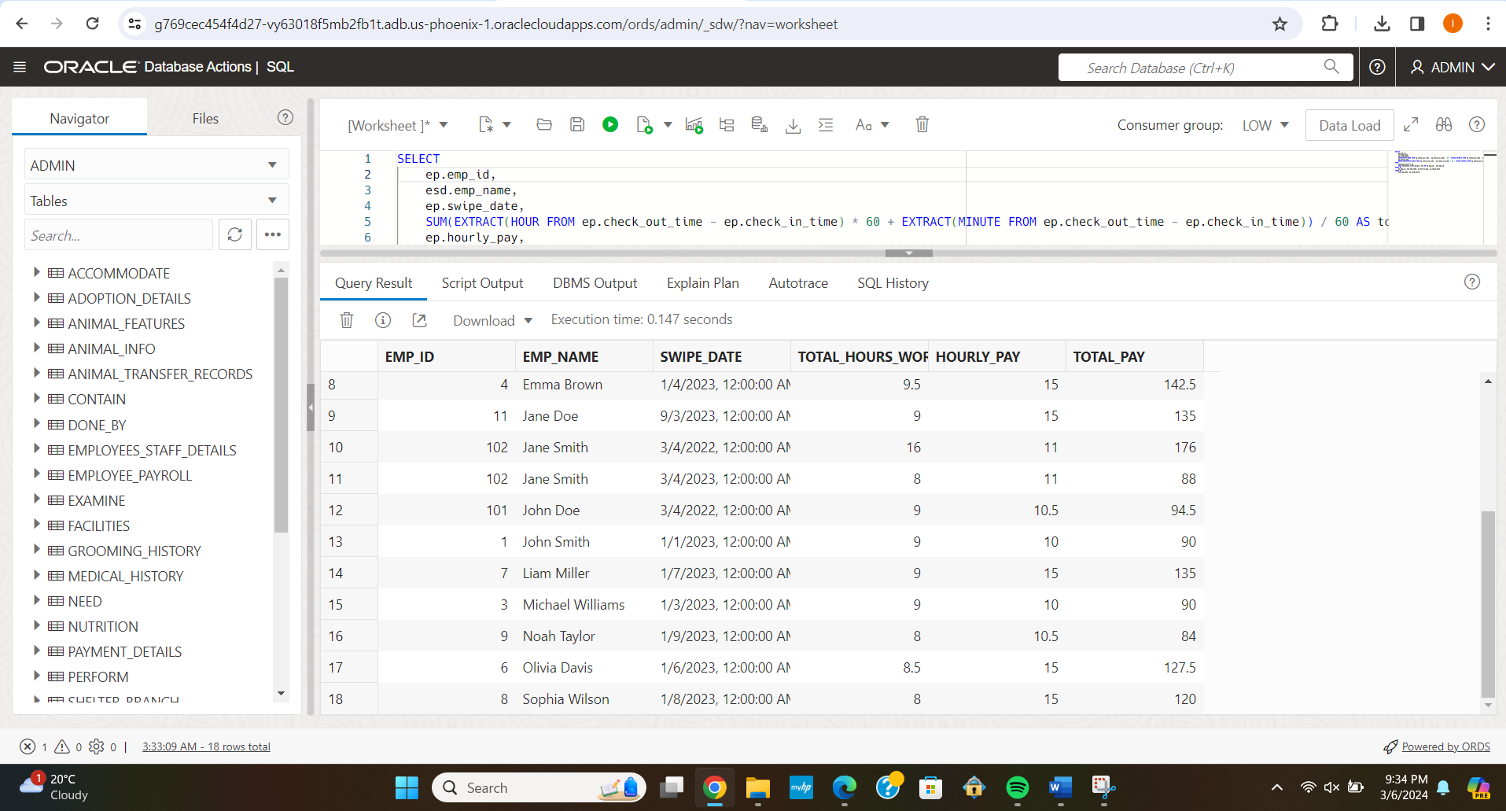

1. Find the number of examinations conducted by each veterinarian:

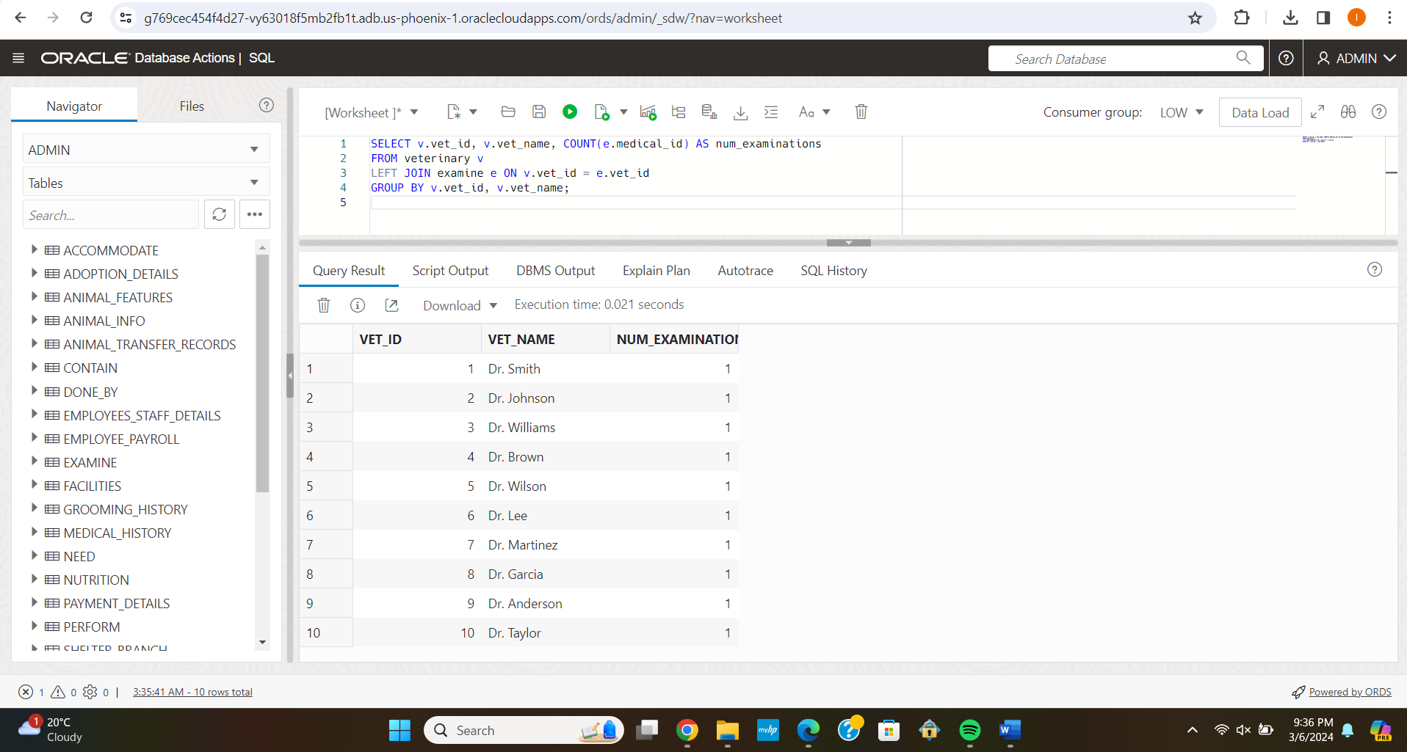

1. Find the total quantity of each type of food needed for all animals:

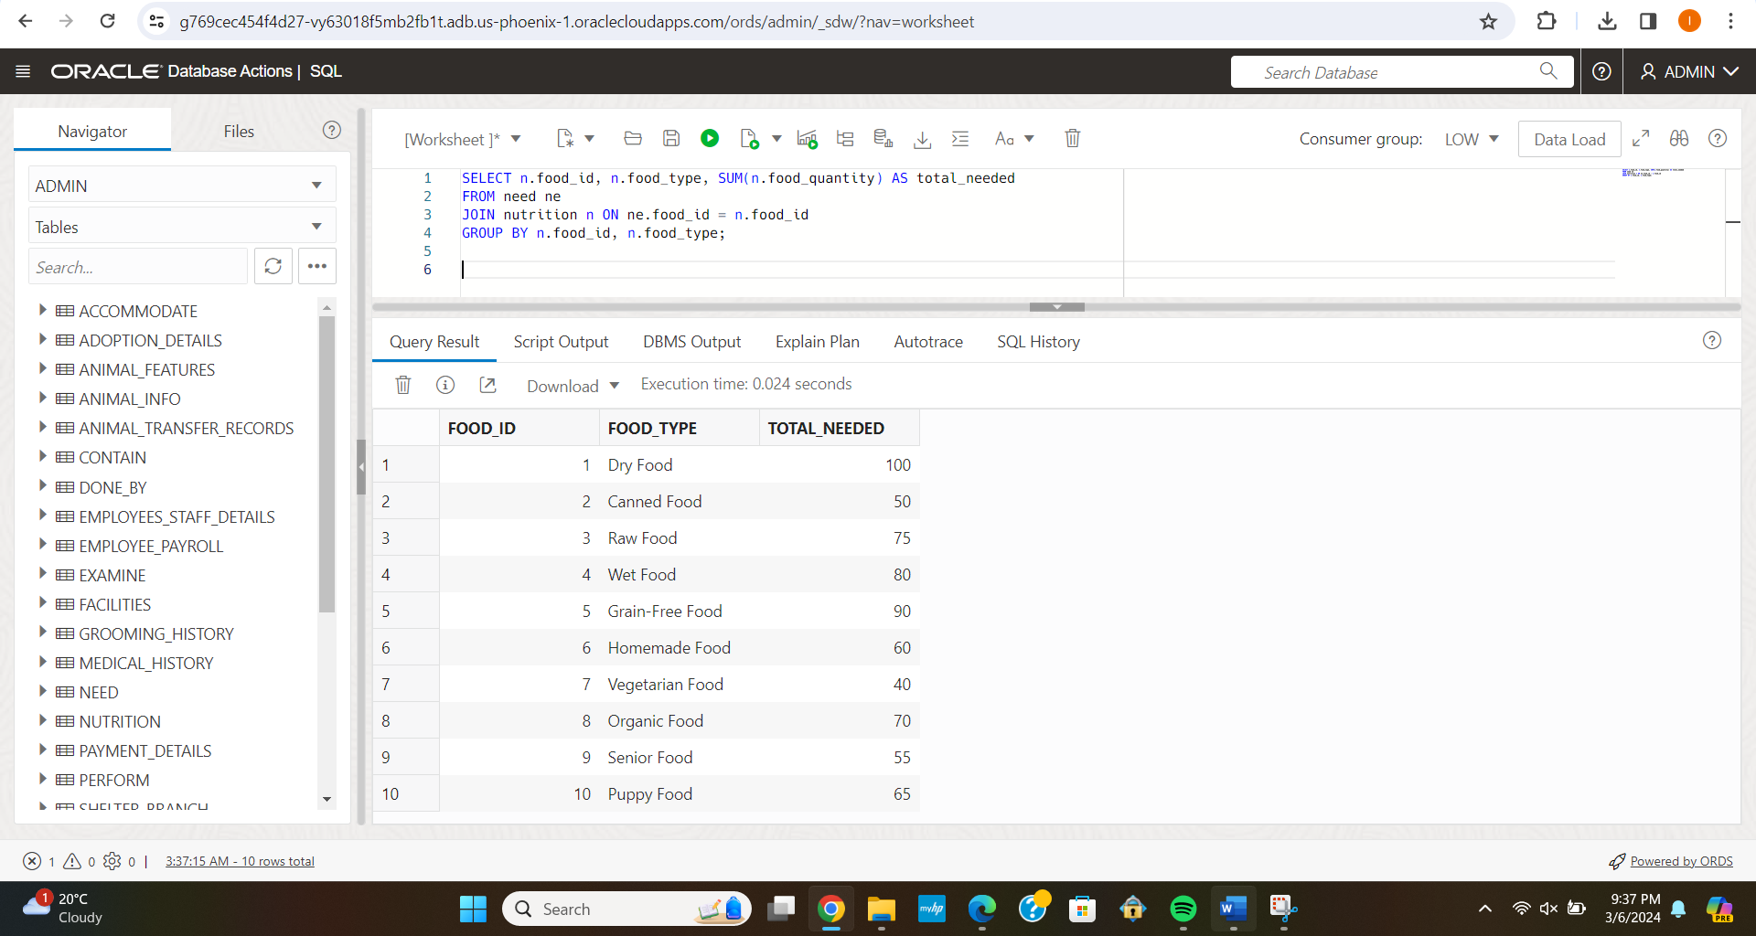

1. List of All Facilities with Play Areas but No Temperature Control

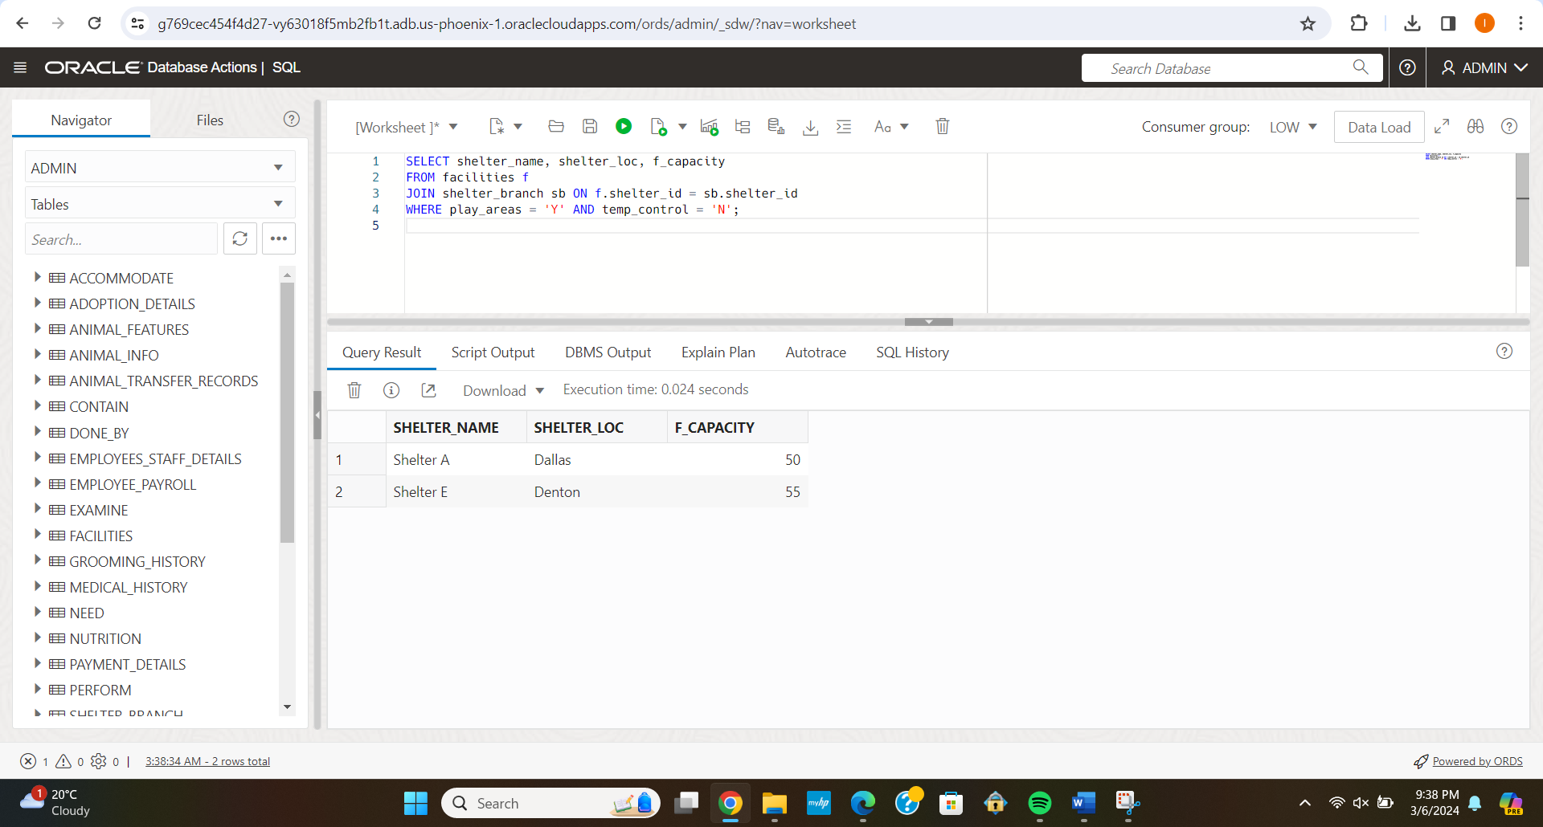

1. Average Duration Between Animal Acquisition and Adoption

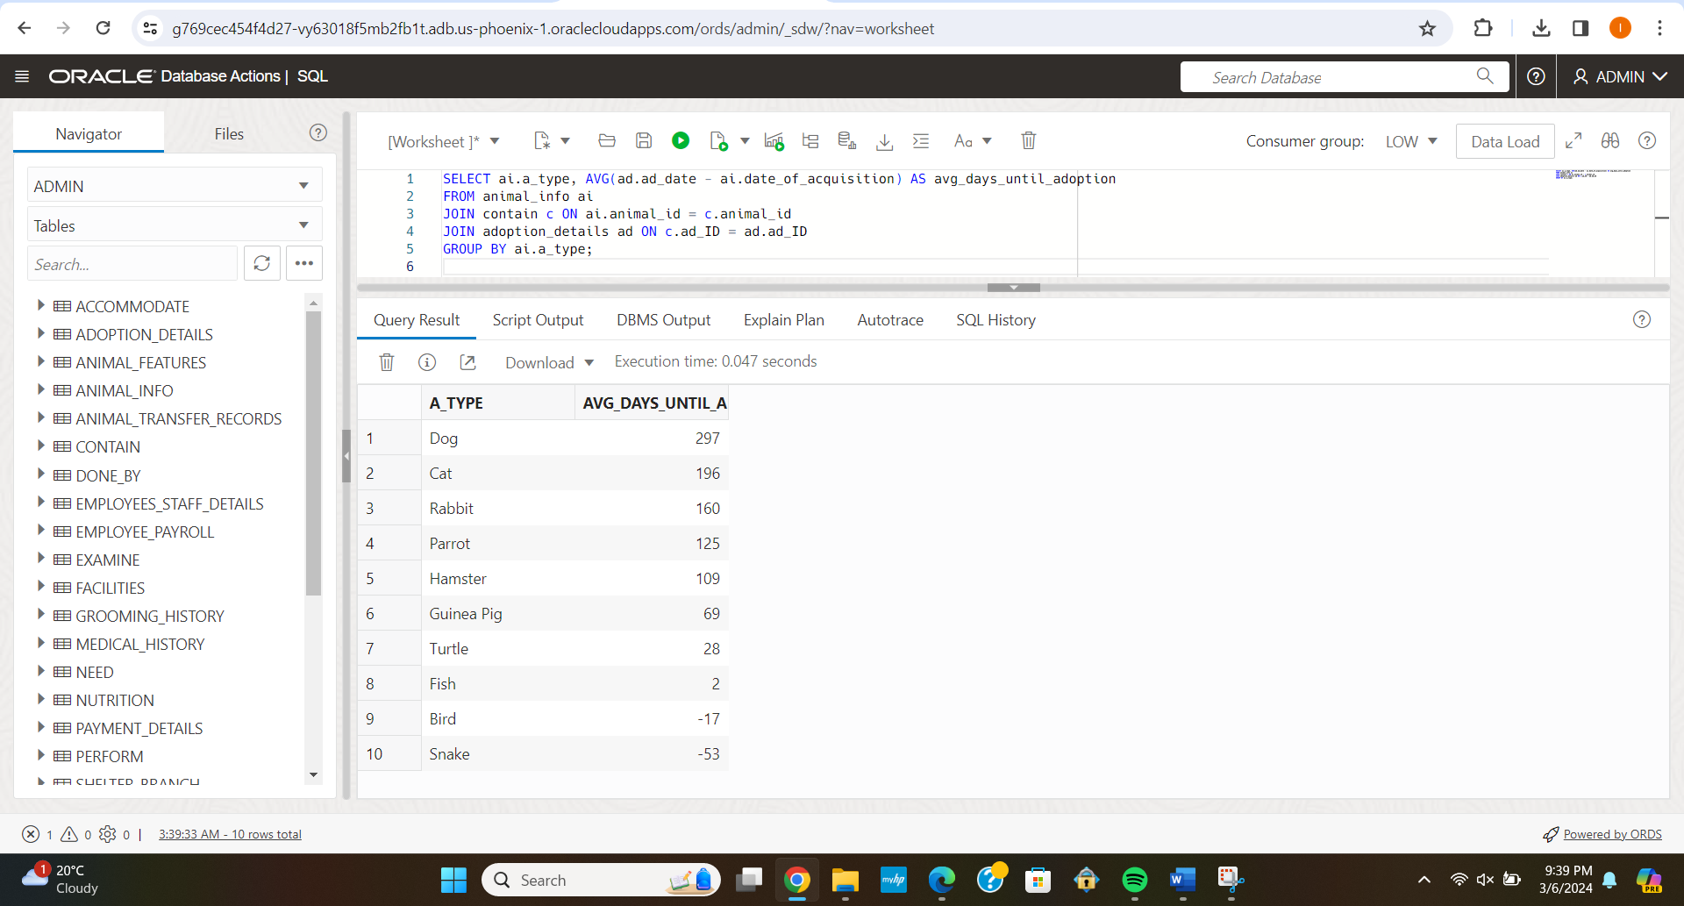

1. Find the number of employees under each manager:

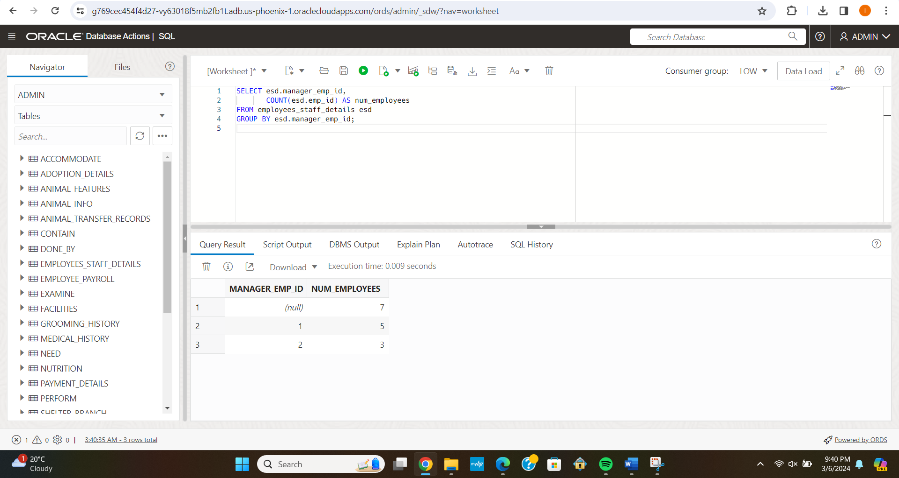

**Update Statements:**

1. Update the vaccination date when the treatment_date is : 2023-08-20

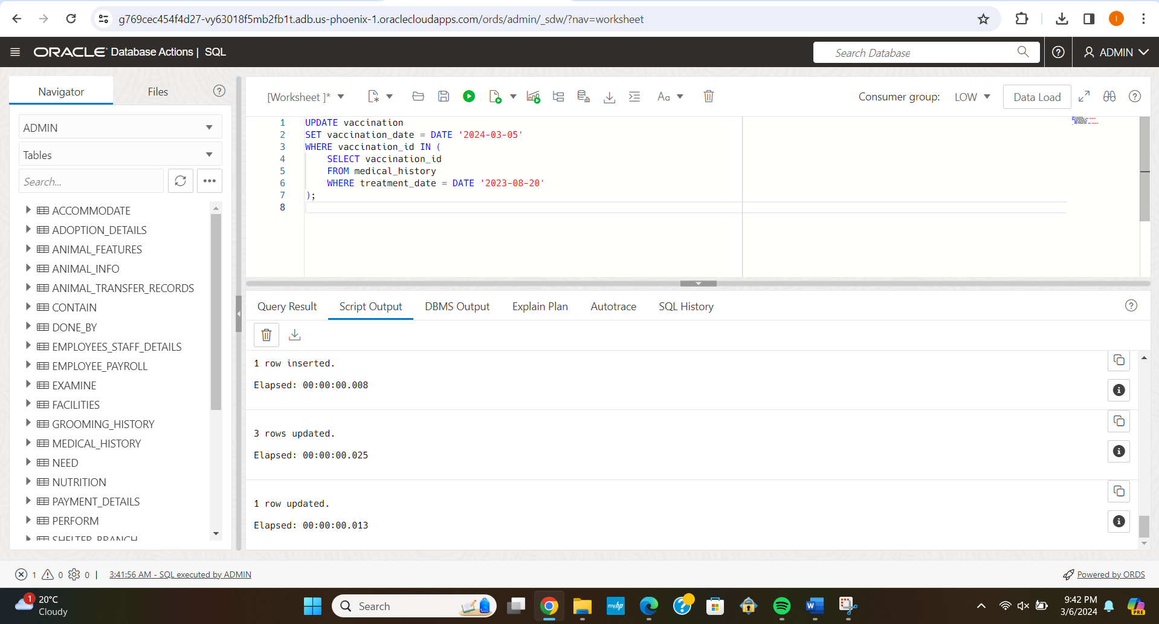

1. Update the transfer date for a specific animal:

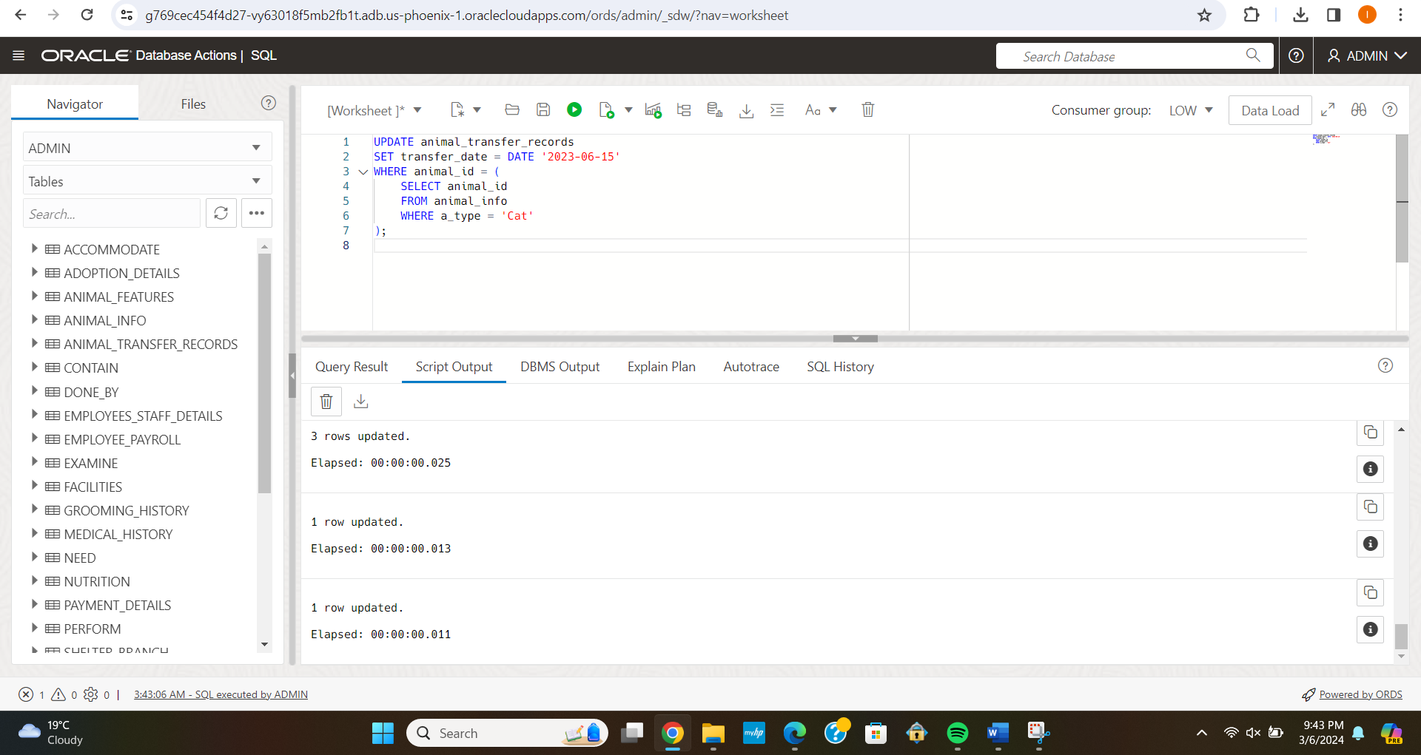

1. Update the food type for animals with diabetes in the nutrition table

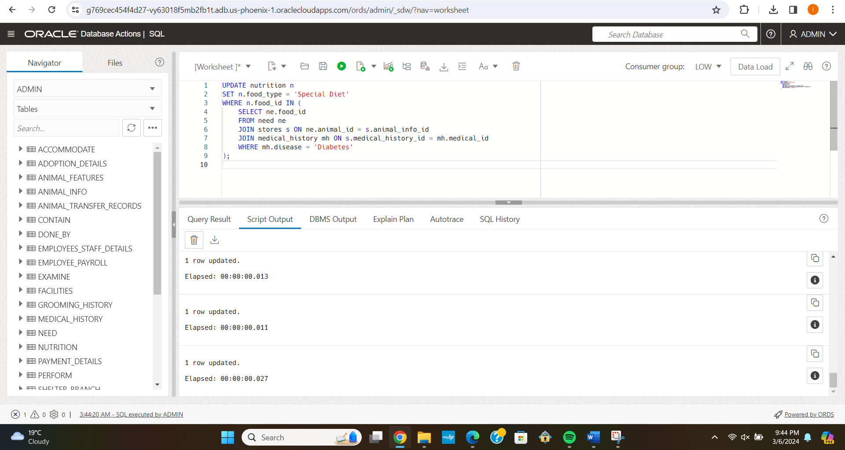

1. Update shelter's capacity based on the number of animals transferred out

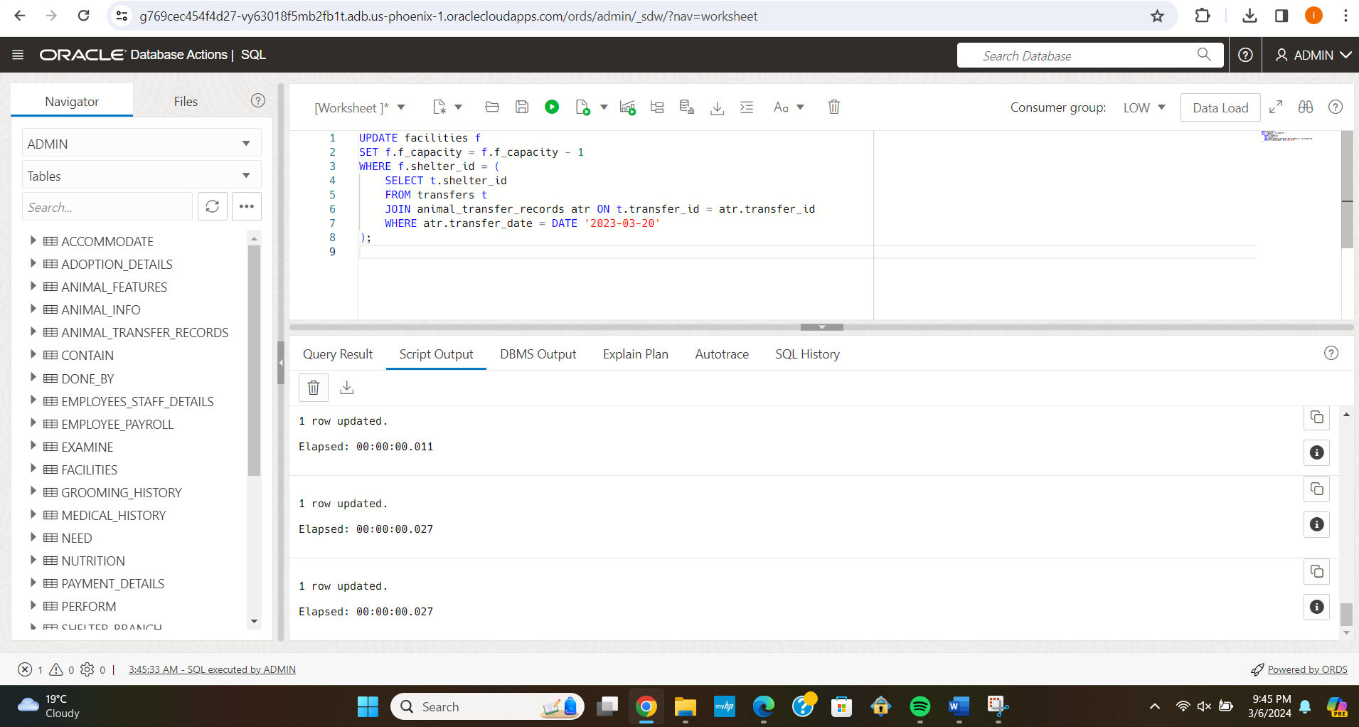

1. Update grooming type for animals with certain features:

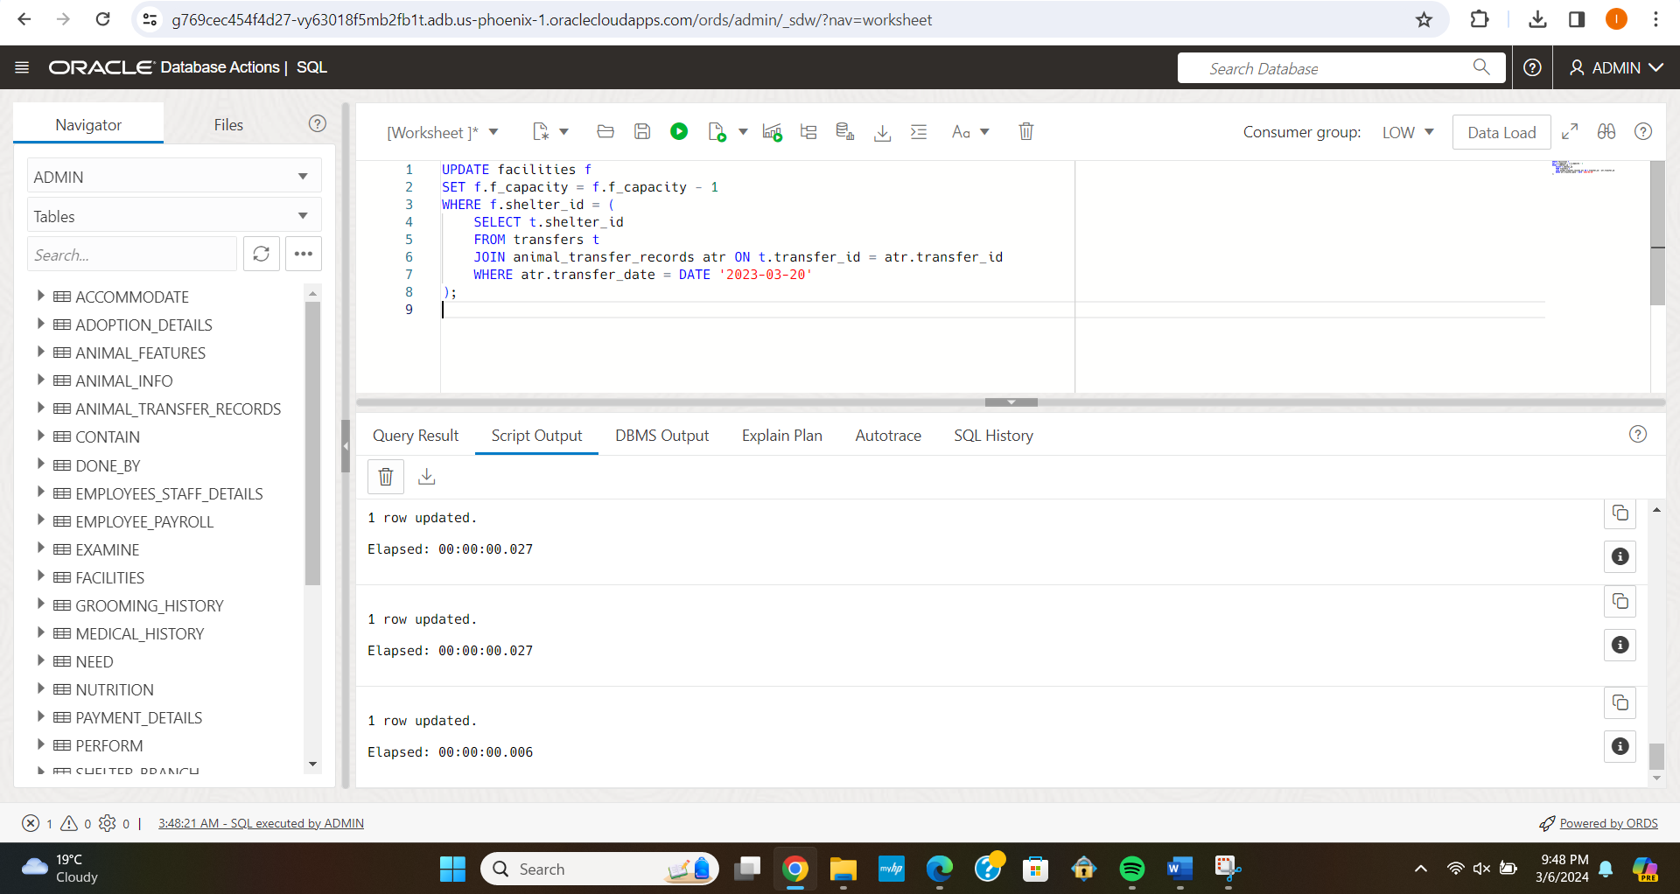

1. Update the training type for employees at top level

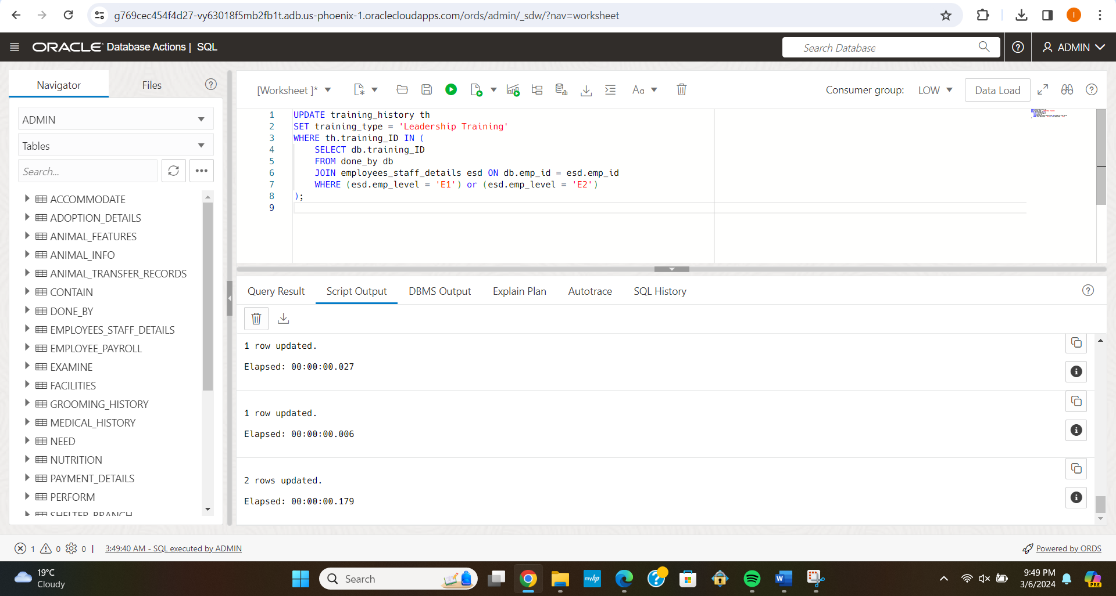

**Delete Statements:**

1. Delete the payroll of the employees who have not done any training:

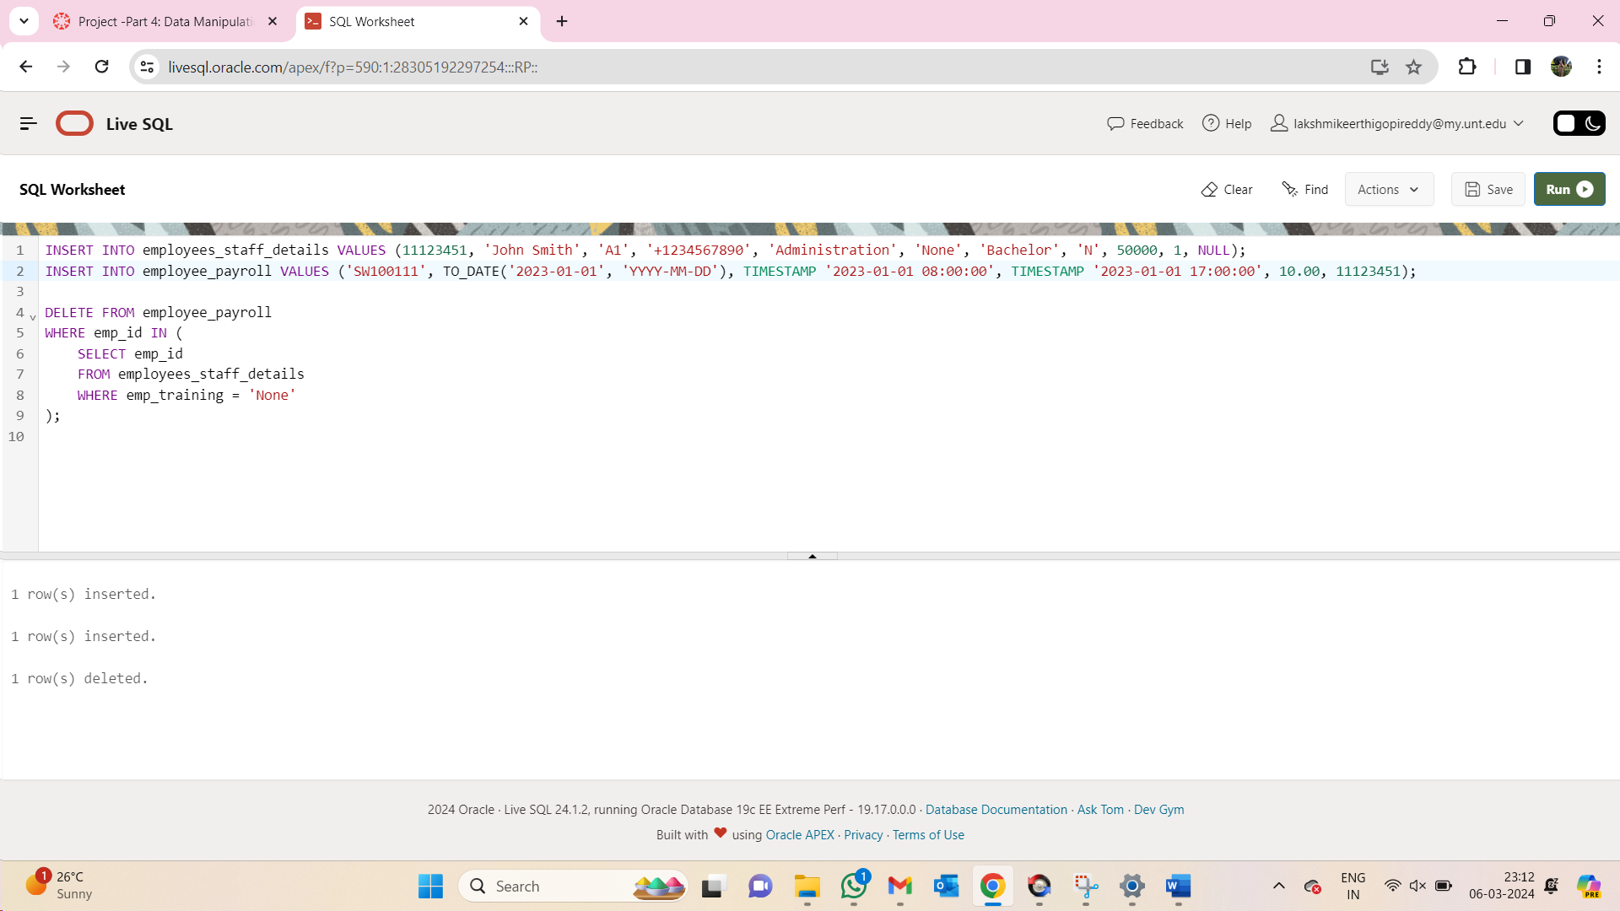

1. Delete all records from the sponsor table for sponsors who have not made any payments:

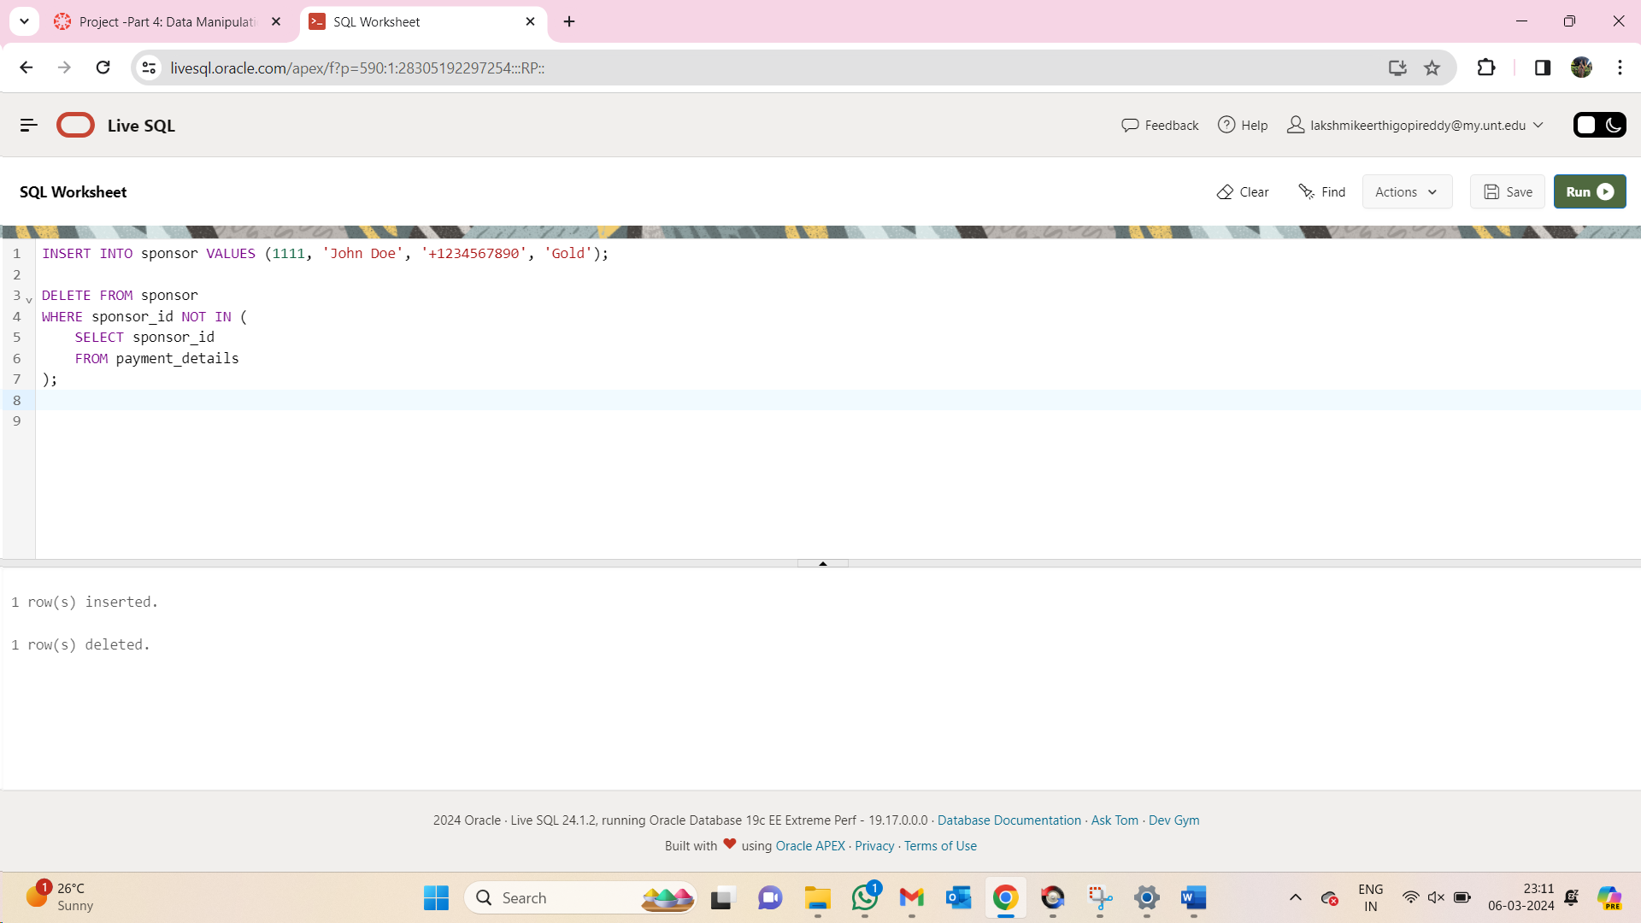

1. Delete all records from the animal_info table where the animals are of type 'Cat', and they have not been transferred to any other shelter, and their vaccination status is not up to date

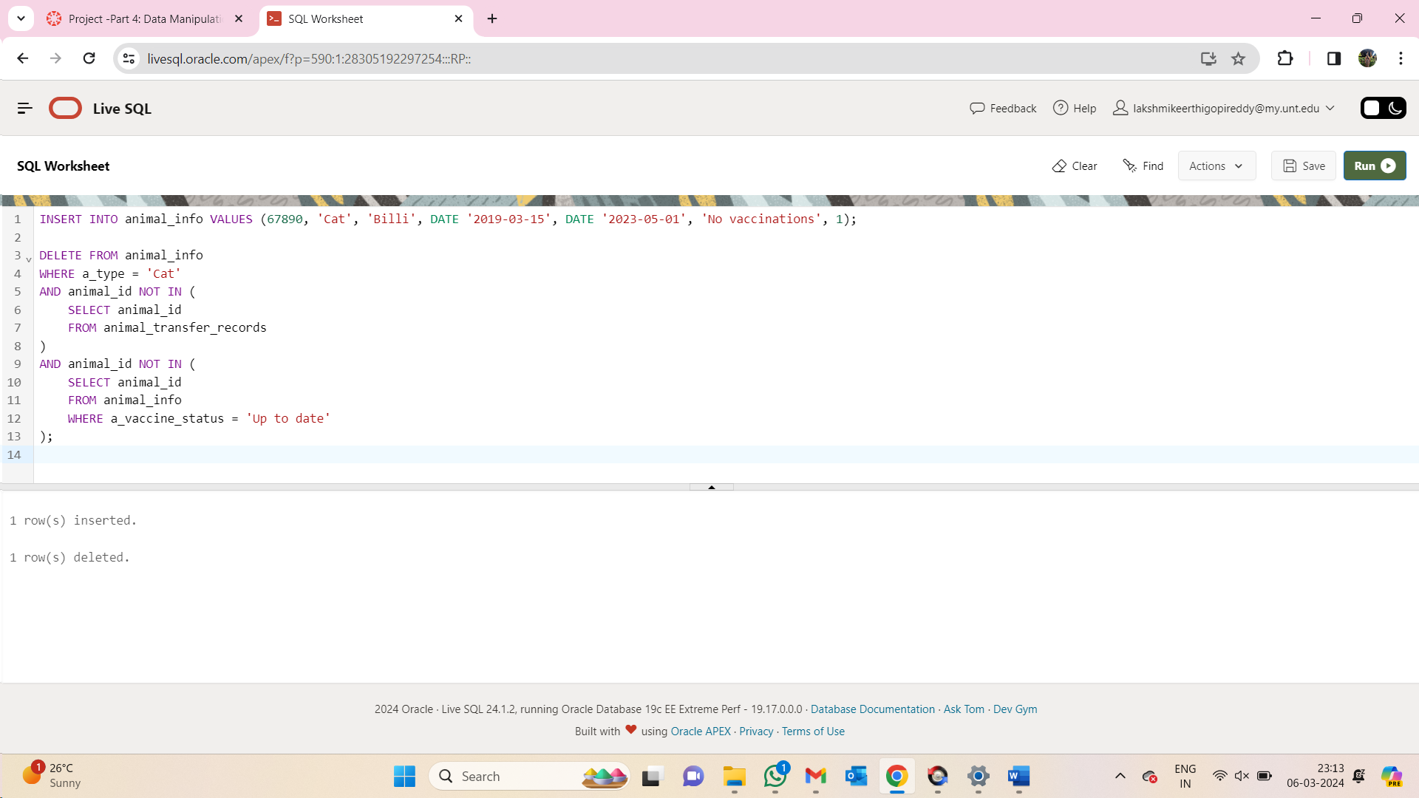

1. Delete the animal transfer record if the animal type is cat and the location is Shelter C:

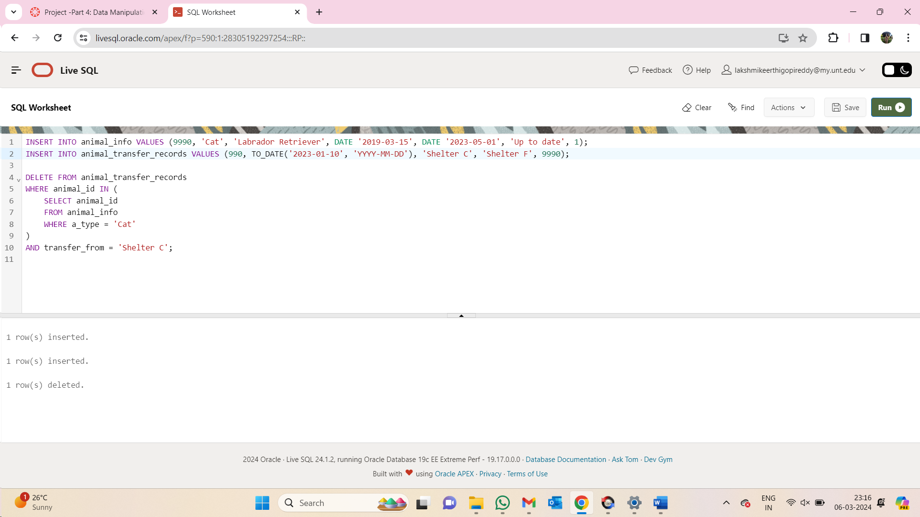

1. Delete medical history of the records where the vaccination dosage is last

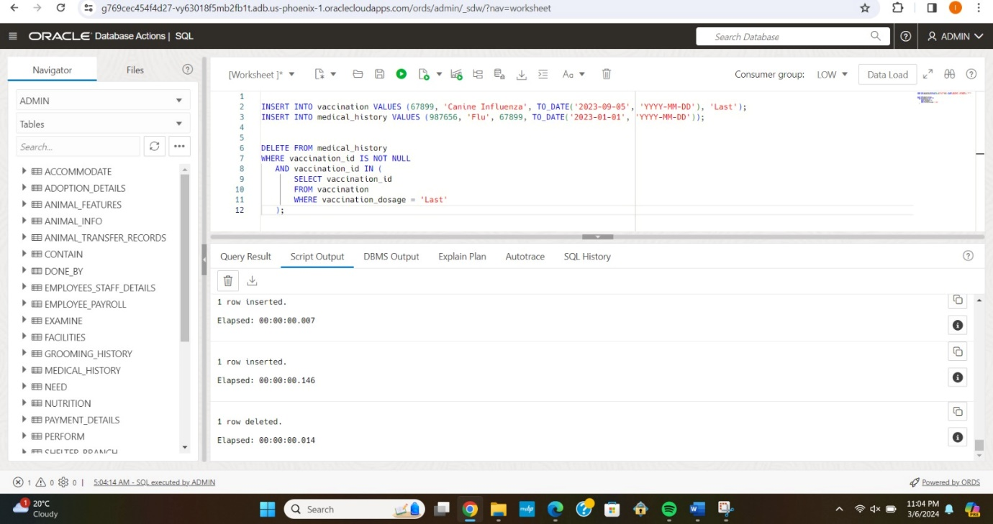

1. Delete the animal information of Dogs which are underweight:

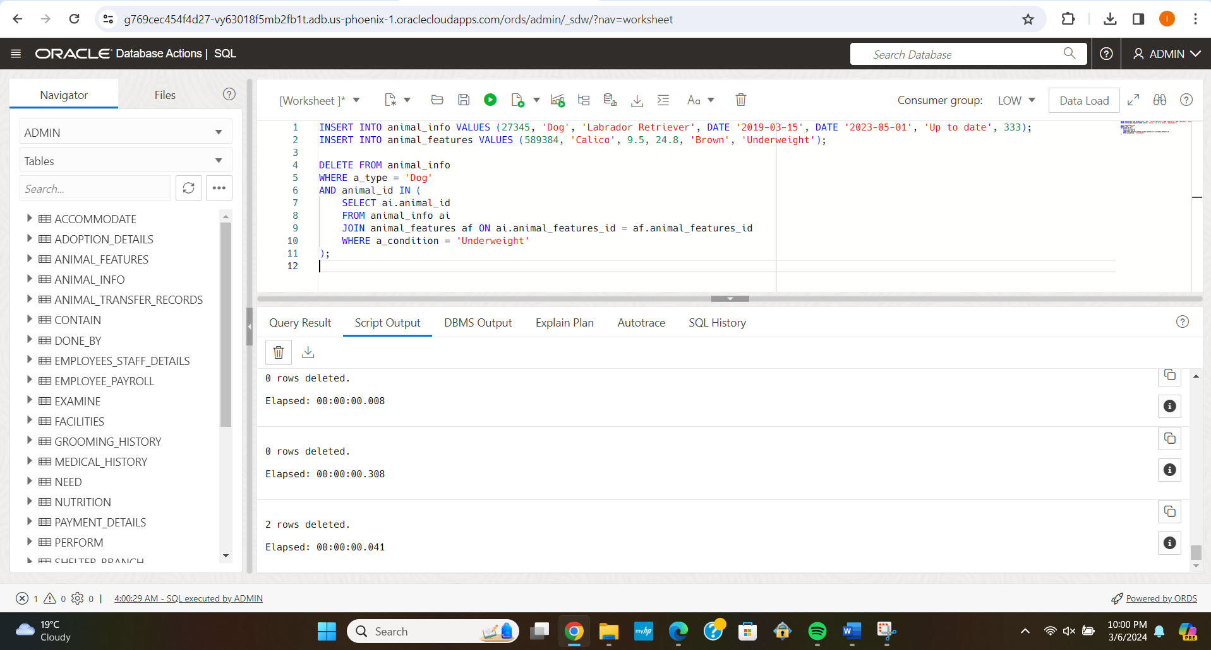

**Individual Contributions:**

My contribution revolved around a series of questions, each with a specific objective.

First, I addressed the issue of finding adoption-ready dogs in different locations. This was not just about the statistics. It was about integrating the creature into loving homes, ensuring that no dog was overlooked. After carefully entering and analysing detailed records, the query is written that allows us to determine which dogs are ready to start their new lives and where they are located.

A healthy diet comes next. Each animal has unique needs, and ensuring they are met with their necessities to their well-being. The query that developed to calculate total food requirements involves more than just math. It was about giving each animal the proper care and attention, and making sure they were healthy, happy and ready for adoption.

The next query is the environmental conditions that directly affect the lives of the animals. It was important to know which of our accommodations had play areas and which does not have temperature control. This effort was to ensure that our facilities were not just adequate but met the physical and emotional needs of the shelters.

Understanding the adoption schedule was also very important. The faster we can move animals from arrival to adoption, the more lives we can save. The query I did to find out the average length of time between acquiring and rescuing an animal. It helps us to know the period from arrival and adoption time.

Finally, examining organizational structure was about understanding the dynamics between managers and their teams to ensuring that the human resources were very well matched. This was to create a supportive, high-performing environment for staff and enabling them to do their best work for the animals. And each line of SQL isn’t just code, It was a stepping stone to a better future for countless animals.